Formatting Floating Point Numbers
To format floating point numbers we use the following format-specifier.
width.precisionf
The width is the minimum number of characters reserved for a value and precision refers to the number of characters after the decimal point. The width includes digits before and after the decimal and the decimal character itself. The f character followed by the precision represents that the format() function will output the value as floating point number. The character f is also known as type code or specifier. There are many other specifiers, as we will see.
By default, all types of numbers are right aligned. If the width is greater than length of the value then numbers are printed right justified with leading spaces determined by subtracting length of the value from width. On the other hand, if the width is smaller than the length of the value then the length of the width is automatically increased to fit the length of the value and no leading spaces are added
To make everything concrete, let's take some examples:
Example 1:
1  2  3  4 | >>>  >>> print(format(34.712, "9.2f"))  34.71  >>>
Try it now
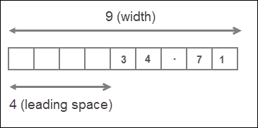
Here width is 9 characters long and precision is 2. The length of number 34.712 is 6, but since the precision is 2, the number will be rounded to 2 decimal places. So the actual length of value is 5. That means the width is greater than the length of the value, as a result value is right justified with 4 (9-5=4) leading spaces.
Example 2:
1  2  3  4 | >>>  >>> print(format(567.123, "5.2f"))  567.12  >>>
Try it now
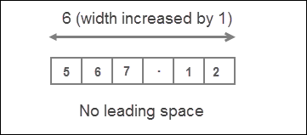
In this case, width is 5 and the actual length of the value is 6 (because the number will be rounded to 2 decimal places). So width is smaller than length of value, as a result, the length of the width is automatically increased to fit the length of the value and no leading spaces are added
We can also omit the width entirely, in which case it is automatically determined by the length of the value.
1  2  3  4  5 | >>>  >>> import math  >>> print(format(math.pi, ".2f"))  3.14  >>>
Try it now
The width is commonly used to neatly line up data in columns.

(as a bounace :)

Formatting Numbers in Scientific Notation
To format a number in Scientific Notation just replace type code from f to e or E.
1  2  3  4  5  6  7  8  9  10  11  12  13 | >>>  >>> print(format(5482.52291, "10.2E"))  5.48E+03  >>>  >>>  >>> print(format(5482.52291, "5.2e"))  5.48e+03  >>>  >>>  >>> print(format(00000.212354, ".3E"))  2.124E-01  >>>  >>>

